
Southern River College
Human Biology
Unit 4
TASK 7
Mutations & Gene Pools (5%)
TYPE: Extended Response
CONTENT: Mutations & Gene Pools
TASK 9: Extended Response – Mutations & Gene Pools (5%)

You will have one week to complete your booklet, before completing an in class validation response to unseen questions. You are allowed to have Part A with you during the validation.

Part B and your references are required to be submitted prior to sitting the validation.
Due Date:
You must include your references in APA referencing format. Hand this in as a separate sheet attached to your note-taking sheet.
To be completed:
- Booklet (to be submitted) 6 marks
- References (APA style) 2 marks
- In Class Validation (Part A as notes ONLY)


Southern River College
Human Biology
Unit 4
TASK 7
Mutations & Gene Pools (5%)
TYPE: Extended Response
CONTENT: Mutations & Gene Pools
This task is in two parts.

Part A requires you to consider gene frequencies in two populations and answering questions relating to it.
Part B involves researching genetic conditions

Part A: Gene frequencies
The ABO blood typing system is governed by allele I^{A} and I^{B}, which are codominant to the i allele. The genotypes and phenotypes that exist are:
I^{A} I^{A} or I^{A} i – type A
I^{B} I^{B} or I^{B}i – type B
I^{A} I^{B} – type AB
ii – type O

The diagram below shows an original population – a hypothetical population of Aboriginals and their blood group genotypes as they may have existed before they migrated to the Australian continent. A number of individuals from this original group migrate to Australia, resulting in the island population as represented in diagram 2.

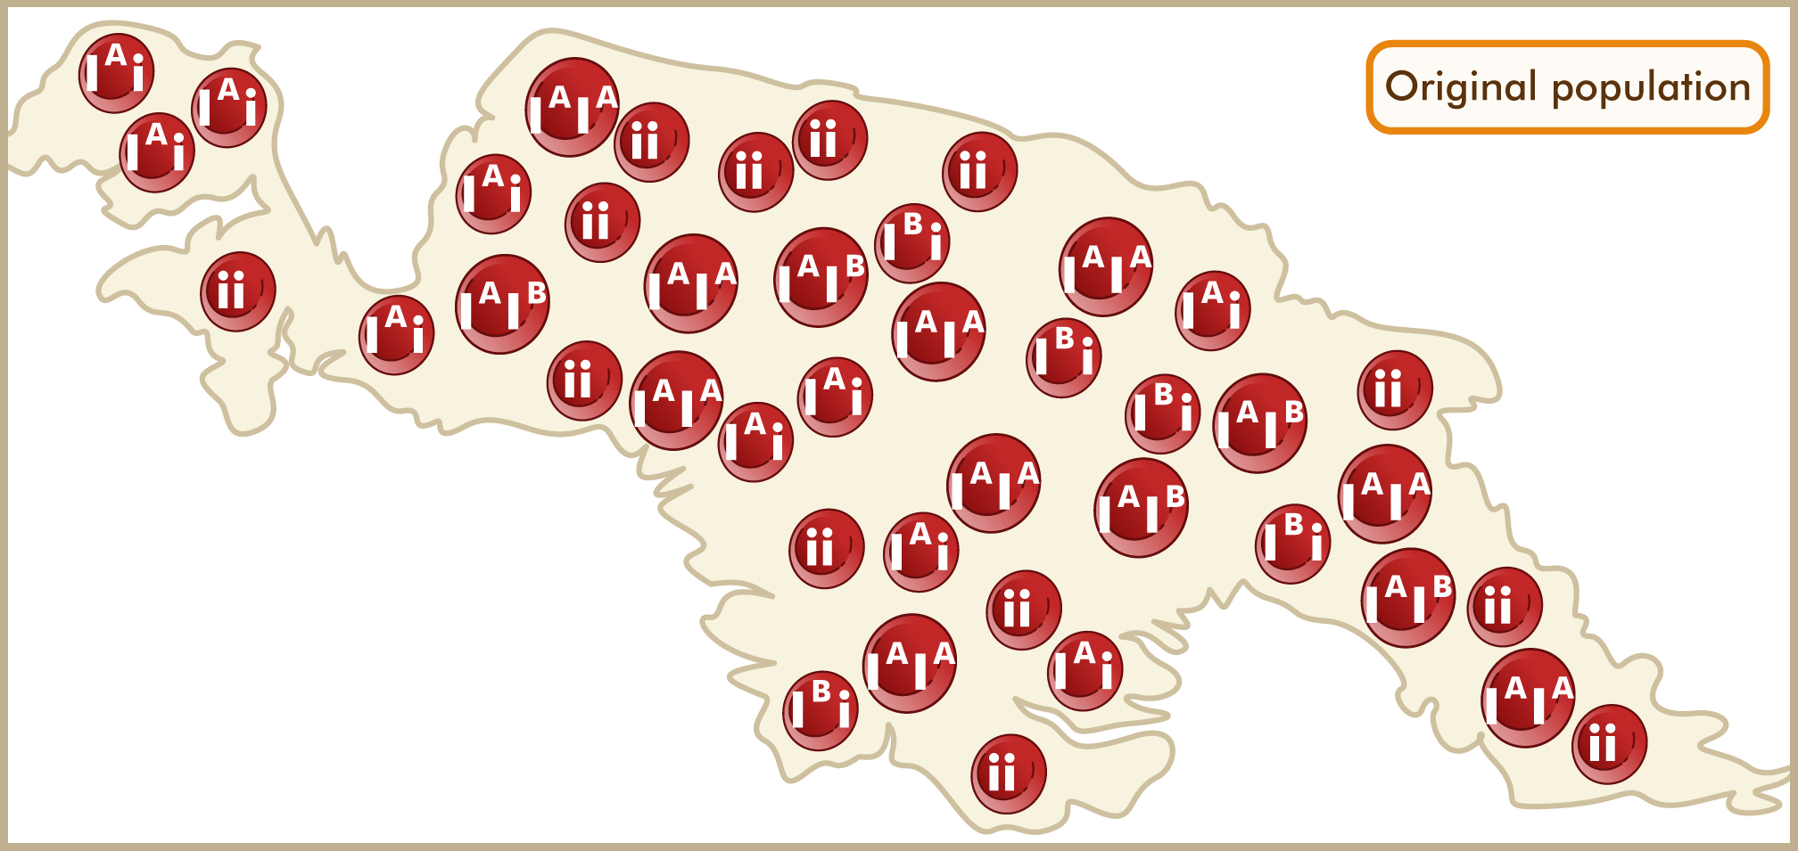
Diagram 1 - hypothetical population of Aboriginals and their blood group genotypes

Diagram 2 - hypothetical population of Aboriginals who have migrated to Australia and their blood group genotypes
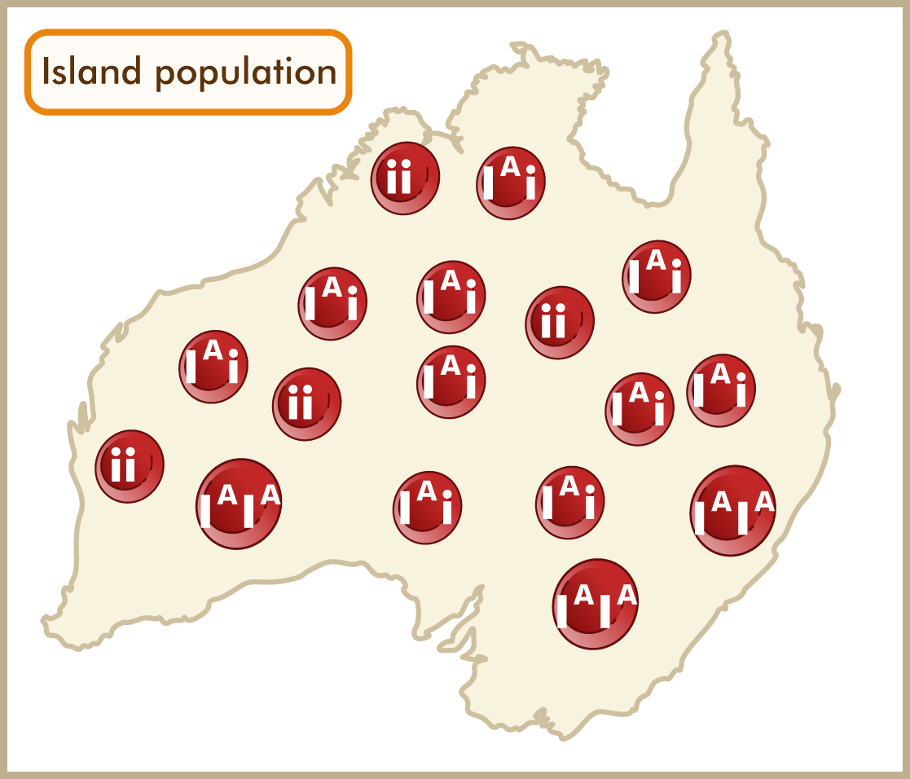

1. Record the following in the tables provided:
a) Count the allele frequencies in both populations.
b) Count the number of allele combinations in both populations.
c) Calculate the allele frequencies as percentages for both, round to 1 decimal place.
number of specific alleles
------------------------------------- x 100
total number of alleles
Gene (allele) frequency (%) =

Original population |  | Number counted | % |  | Island population |  | Number counted | %
Allele types  Total = _____ | I^{A} |  |  |  | Allele types  Total = _____ | I^{A}
 | I^{B} |  |  |  |  | I^{B}
 | i |  |  |  |  | i
Allele combinations  Total = _____ | I^{A}I^{A} |  |  |  | Allele combinations  Total = _____ | I^{A}I^{A}
 | I^{A}i |  |  |  |  | I^{A}i
 | I^{B}I^{B} |  |  |  |  | I^{B}I^{B}
 | I^{B}i |  |  |  |  | I^{B}i
 | I^{A}I^{B} |  |  |  |  | I^{A}I^{B}
 | ii |  |  |  |  | ii

2. Calculate the percentage of phenotype frequencies for each of the following:
Round to 1 decimal place

Original phenotype frequencies (%) |  |  |  |  | Island phenotype frequencies (%)
Type A | Type B | Type AB | Type O |  | Type A | Type B | Type AB | Type O

Answer the following questions, as they relate to the given information on the populations.
3. Describe how the allele frequencies of the two populations differ. Explain how this difference occurred.

__________________________________________________________________________________________________________________________________________________
_________________________________________________________________________
_________________________________________________________________________
_________________________________________________________________________
_________________________________________________________________________
___________________________________________________________________________________________________________________________________________________________________________________________________________________________
_________________________________________________________________________
4. Predict what will happen to the allele frequencies for both populations after many generations.
Use data from the table to support your response.

_________________________________________________________________________
_________________________________________________________________________
_________________________________________________________________________
_________________________________________________________________________
_________________________________________________________________________
_________________________________________________________________________
_________________________________________________________________________
_________________________________________________________________________
_________________________________________________________________________

5. This type of colonisation of the island can be identified by which term?

_________________________________________________________________________
6. Name ALL other processes which could further alter the allele frequencies of the island population. Describe these processes with specific reference to the island population.
i. _________________________
_________________________________________________________________________
_________________________________________________________________________
_________________________________________________________________________
ii._________________________
_________________________________________________________________________
__________________________________________________________________________________________________________________________________________________
iii. _________________________
_________________________________________________________________________
_________________________________________________________________________
_________________________________________________________________________
iv.__________________________
_________________________________________________________________________
__________________________________________________________________________________________________________________________________________________
v. _________________________
_________________________________________________________________________
_________________________________________________________________________
_________________________________________________________________________
vi. _________________________
__________________________________________________________________________________________________________________________________________________
_________________________________________________________________________
vii. _________________________
__________________________________________________________________________________________________________________________________________________
_________________________________________________________________________

Part B: Incidence of specific genetic diseases in populations:
Genetic disease | Cause | Genotype  (Using  T & t) | Specific population affected | Symptoms  (max 3) | Treatment | Why is this disease still present in populations?
Tay Sach’s
(chronic form)

Thalassemia
- Alpha

- Beta

Sickle cell anaemia

